Nama : Revan Febriansyah

NIM : 18090091

Kelas : 5

PRAKTIKUM 2

1. Source Code

latihan1-> application/controller

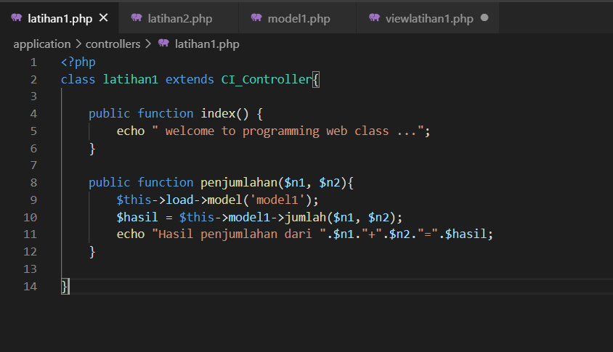

latihan2 -> application/controller

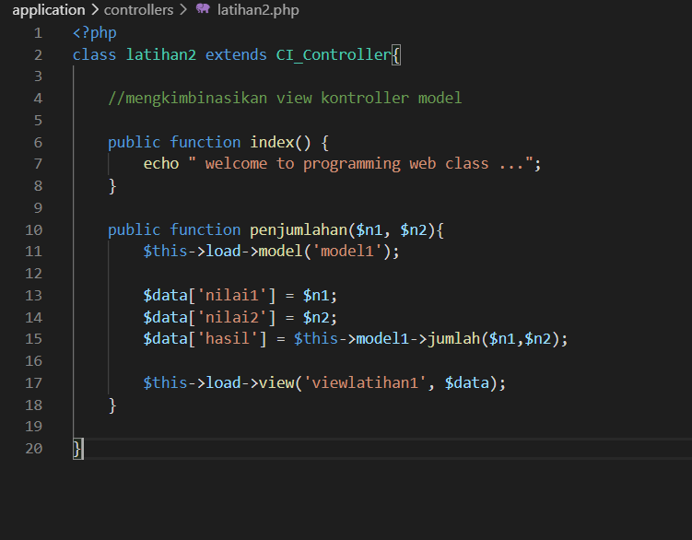

model1 -> application/model

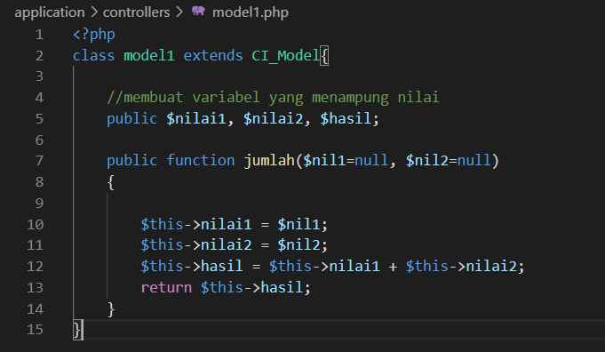

viewlatihan1.php->application/view

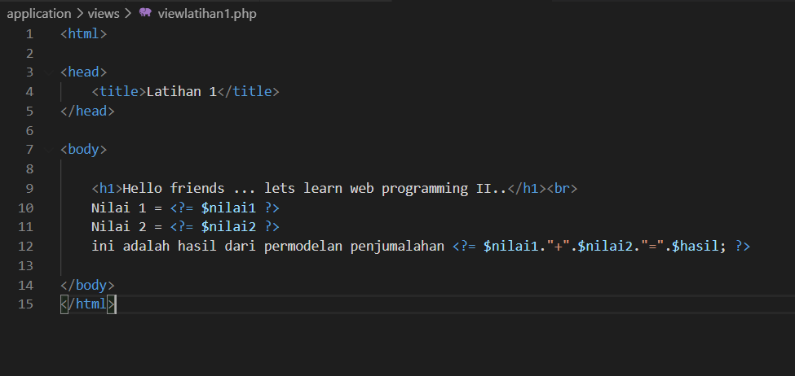

1. URL

<http://localhost/pustaka_revan/index.php/latihan2>

http://localhost/pustaka_ revan /index.php/latihan2/penjumlahan/5/7

[http://localhost/pustaka_ revan /index.php/latihan1/penjumlahan/10/15](http://localhost/pustaka_wisnu/index.php/latihan1/penjumlahan/10/15)

1. Capture Hasil

**Hasil run latihan 2**

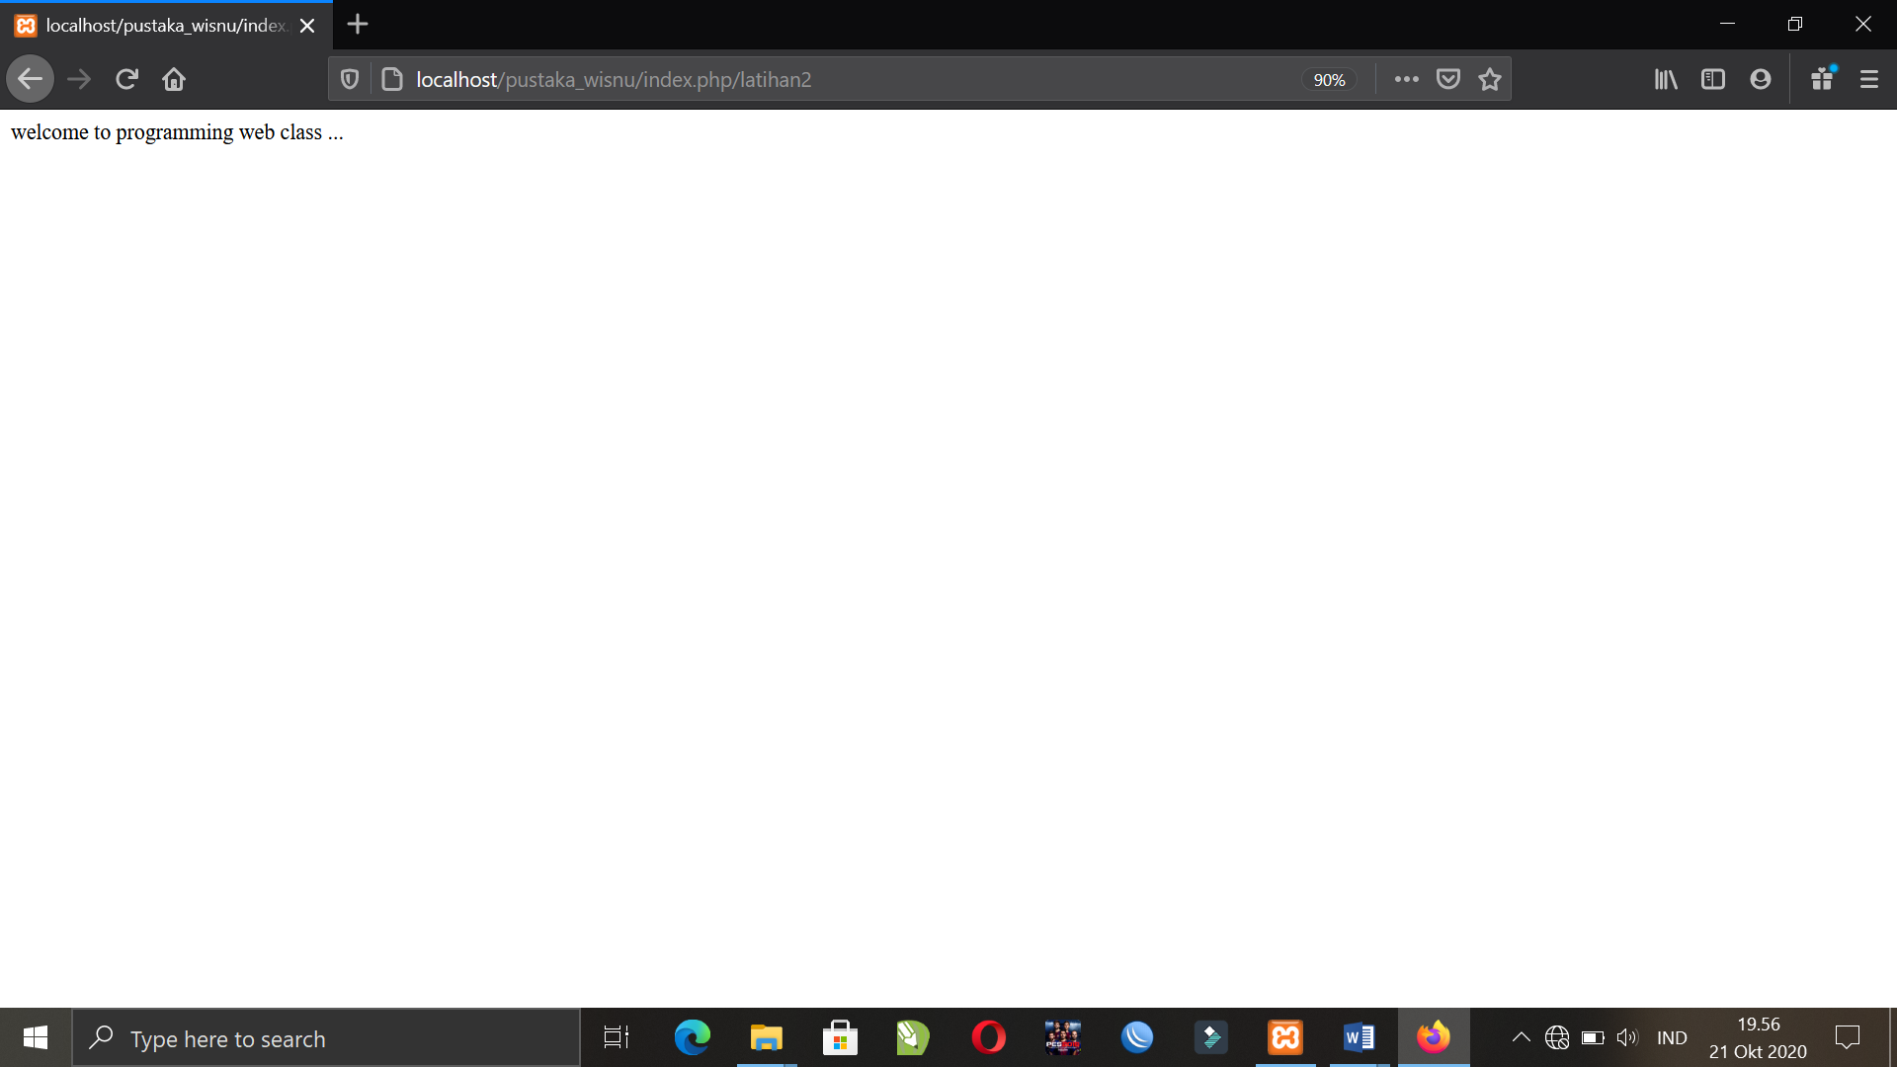

**Hasil run penjumlahan latihan 2**

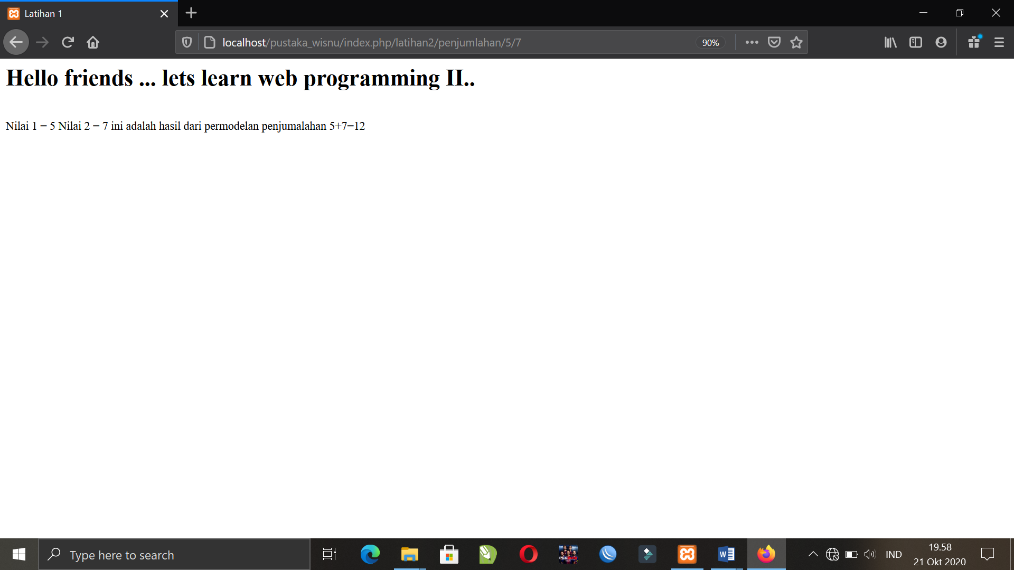

**Hasil run penjumlahan latihan 1**

